MAIN

Log in

About us

gallery

home

package

home

home

Login temp

Sign in

Sign-pass

Sign -fail

fail

login

Log pass

Log fail

Update fail

update

success

form pass

Payment final

Form fail fail

payment

Update pass

Total pages created = 21

Remove = 5

Final = 17

User guide !

1: you can listen music if web page open

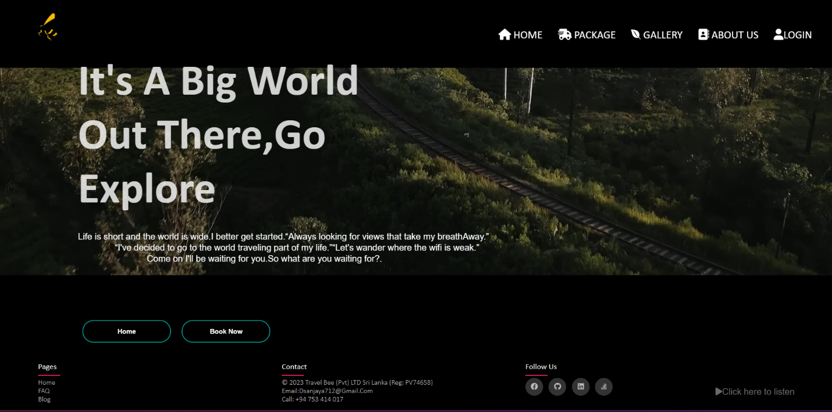

2: light box effect

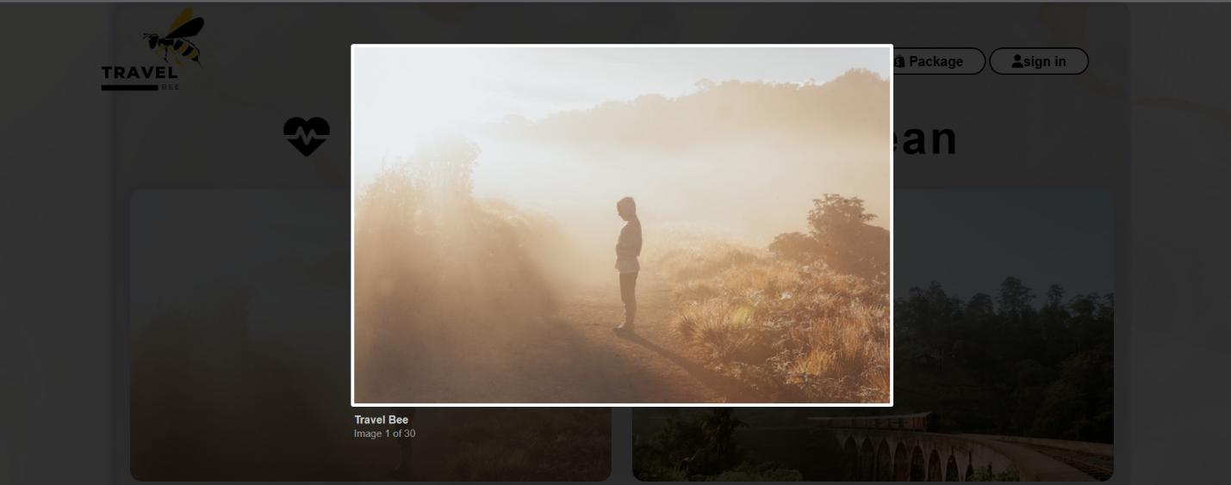In the gallery if you click picture then you can view full

3 : all links are work:

You can click!



4: this is real login system

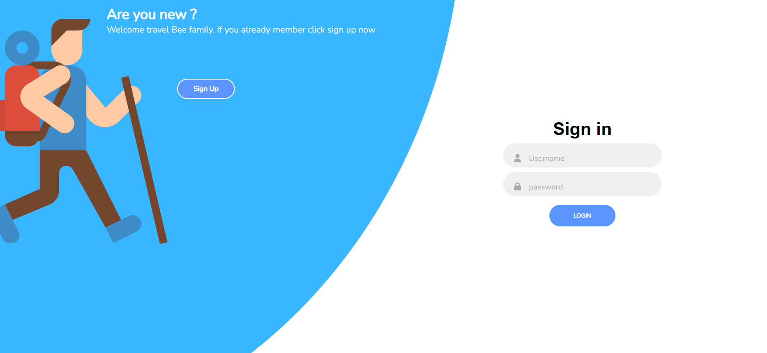

5: inputs must be not null

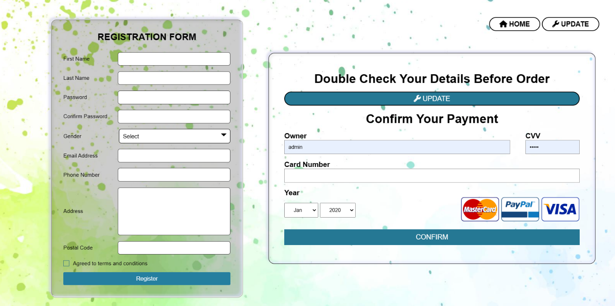

6 : you can update your data

Enter email 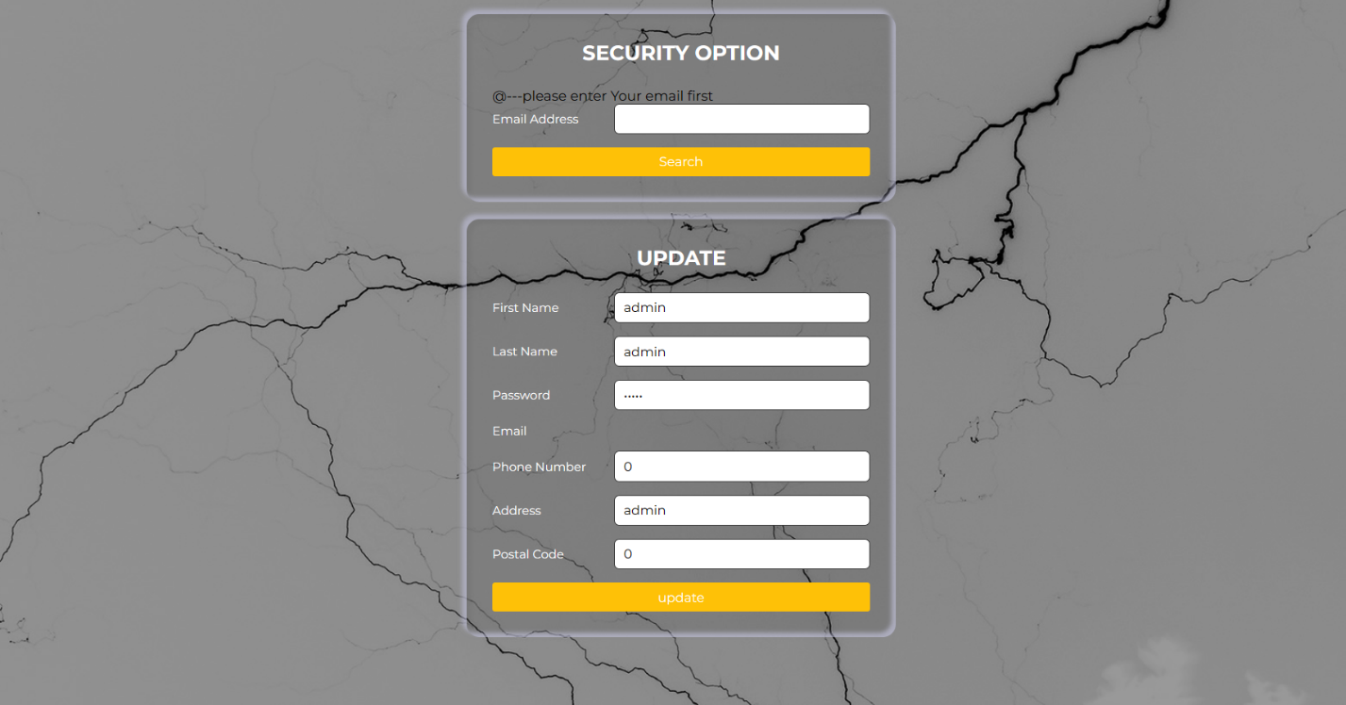

(default admin keyword all you can access)

Video Edite - capcut and windows clipchamp

Image Edite = canva and pixel

Cording : PyCharm professional and phpstorm

C78833 --sanjaya danushka;